**Market Insights Challenge: Report on University Cafeteria Services**

  
  
**Submitted by:**

Mehak Kanwal (2022-BBIT-15)

Hassan Ali (2022-BBIT-46)

Junaid Bukhari (2022-BBIT-70)

Moattar Khanam (2022-BBIT-84)

Humaira Fatima (2022-BBIT-87)

Komal Muqaddas (2022-BBIT-89)

Sajal Arshad (2022-BBIT-90)

**Submitted to:**

Miss Shaheera Ahamad

*Institute of Business and Management*

***University of Engineering and Technology Lahore, Pakistan***

Table of Contents

**1 Introduction:** 4

1.1 Background 4

1.2 Problem Statement 4

1.3 Research Objectives and Questions 4

1.4 Scope 5

**2 Literature Review:** 5

2.1 The Role of Food Quality in Student Satisfaction 5

2.2 The Impact of Hygiene on Satisfaction 5

2.3 Student Satisfaction and the Relationship Between Food Quality and Hygiene 6

2.4 Factors Influencing Student Satisfaction with University Cafeteria Services 6

2.5 Gaps in Literature 6

**3 Methodology:** 7

3.1 Research Design 7

3.2 Data Collection Methods 7

3.3 Sampling Techniques 7

3.4 Quantitative Analysis 7

3.5 Ethical Considerations 8

**4 Key Findings:** 9

4.1 Descriptive statistics 9

4.2 Inferential Statistics 10

4.3 Framework of Research 7

4.4 Key Variables 8

**Conclusion** 13

**Recommendations** 13

**Limitations** 15

**References** 16

**Abstract**

This research examines the critical factors influencing student satisfaction with university cafeteria services, focusing on the quality of food, and hygiene. Cafeterias are integral to student life, providing a space for relaxation, social interaction, and nourishment. However, substandard food, unclean environments, and poor hygiene practices can significantly impact the student experience and overall satisfaction. A descriptive research design was utilized, employing a survey-based approach to collect data from 115 students across various departments of the university.

The findings reveal that while students appreciate the variety of food options available, concerns about food quality and inconsistent hygiene practices are prevalent. Key issues identified include delays in service during peak hours, untidy seating areas, and dissatisfaction with the freshness of food items.

Based on these findings, the study offers actionable recommendations to improve cafeteria services, such as implementing stricter hygiene protocols, enhancing food quality control measures, and streamlining service operations during busy periods. This research highlights the importance of well-maintained cafeteria services in fostering student satisfaction and enhancing their overall university experience. The insights gained from this study aim to assist the university administration in making informed decisions to improve cafeteria services and create a better environment for students.

# **1 Introduction:**

### 1.1 Background

University cafeterias play a vital role in the daily lives of students, serving as more than just places to eat. These spaces are hubs for relaxation, social interaction, and re-energizing during busy academic schedules. A well-maintained cafeteria with high-quality food, clean surroundings, and hygienic practices contributes significantly to student satisfaction and their overall university experience. It becomes a focal point where students form lasting memories and connections, reinforcing their sense of belonging on campus.

However, maintaining a high standard in university cafeteria services is not without challenges. Common issues such as inconsistent food quality and poor hygiene practices can lead to dissatisfaction among students. These problems not only affect the health and well-being of the students but also shape their perception of the institution. Universities must prioritize addressing these concerns to ensure their cafeterias remain welcoming and meet the needs of their diverse student population.

### 1.2 Problem Statement

Despite their importance, university cafeterias often struggle to meet the expectations of students when it comes to food quality and hygiene. Complaints about unclean dining areas, poor food handling, and lack of variety have become common. These issues can result in a decline in student satisfaction, negatively impacting their overall university experience. Addressing these concerns is essential to maintain a positive reputation for the institution and to foster a healthy and enjoyable campus environment.

### 1.3 Research Objectives and Questions

This study aims to evaluate the factors affecting student satisfaction with university cafeteria services, specifically focusing on food quality and hygiene. By understanding student preferences and pain points, the research seeks to provide actionable recommendations for improving cafeteria standards.

Key objectives include:

* Assessing how food quality impacts student satisfaction.
* Analyzing the role of hygiene in shaping student perceptions.
* Identifying areas of improvement for cafeteria management.

Research Question:

How does the quality of food and hygiene effects students' satisfaction in university cafeterias?

### 1.4 Scope

This research is based on a market survey conducted among university students to understand their experiences and satisfaction levels with cafeteria services. The survey aimed to collect data on key aspects such as food quality and hygiene practices. While the sample size is focused on students from a single university, the findings are expected to provide valuable insights into common challenges and expectations that students have regarding cafeteria services.

The primary focus of this study is on student satisfaction and the factors influencing it, specifically related to food quality and hygiene. Broader operational concerns, such as cafeteria management strategies, supply chain logistics, or budgetary constraints, are outside the scope of this research. Instead, the study aims to address user-specific feedback and identify actionable areas for improvement.

The insights gathered from this research are intended to help university administrations enhance cafeteria services by addressing student concerns. By focusing on delivering better food quality and ensuring hygiene standards, universities can foster a more positive and satisfying environment for their students, contributing to overall campus well-being and satisfaction.

# **2 Literature Review:**

### 2.1 The Role of Food Quality in Student Satisfaction

Food quality plays a significant role in shaping student satisfaction in university cafeterias. Studies have consistently shown that students place high importance on the taste, freshness, and nutritional value of food (Sweeney et al., 2021). According to Latham et al. (2020), students are more likely to return to cafeterias that offer a variety of healthy and appealing food options. The quality of ingredients and food preparation directly impact students' perceptions of the cafeteria. For example, students who value fresh and healthy meals are more satisfied with cafeterias that emphasize quality ingredients and nutritional balance (Tao et al., 2023). Additionally, food that is served quickly and at the right temperature enhances the overall dining experience, leading to higher satisfaction (Chen et al., 2021). Law et al. (2004) pointed out that waiting time and other factors such as environment, seats availability and foods quality are all significantly influence customer satisfaction.

### 2.2 The Impact of Hygiene on Satisfaction

and hygiene are essential components of the cafeteria experience, influencing student perceptions and satisfaction. A clean cafeteria environment, including well-maintained tables, floors, and kitchen areas, is linked to students’ comfort and trust in the cafeteria. Poor hygiene or an unclean dining environment can deter students from returning, as it raises concerns about the safety and quality of the food served (Vargas et al., 2023).

Furthermore, hygiene practices such as proper food handling and storage are crucial in ensuring student safety. A study by Givens et al. (2021) emphasized that students are highly sensitive to issues like cross-contamination and improper food storage, which can lead to foodborne illnesses. Cafeterias with rigorous hygiene standards are more likely to gain the trust of students, thereby increasing satisfaction and loyalty (Moore et al., 2023).

### 2.3 Student Satisfaction and the Relationship Between Food Quality and Hygiene

The overall satisfaction of students in university cafeterias is a combination of several factors, with food quality and hygiene being the most influential. Studies show that students who rate food quality highly are more likely to report a positive overall experience in the cafeteria (Bryson & Gallo, 2020). Similarly, maintaining hygiene standards directly enhances satisfaction, as students feel more comfortable and secure in a well-maintained environment. Research by Simmons & Wilson (2022) found that the perception of cleanliness, including both the dining area and kitchen, was strongly associated with students’ likelihood of choosing that cafeteria for their future meals. Cha and Seo (2019) found that some attributes i.e., menu, taste, price contribute significantly towards student’s satisfaction in universities’ cafeteria. Similar sentiments are found in the study conducted by Smith et al. (2020) in which they found that food quality, ambience of the place, value for money, options for food and drinks, and quality of service are critical to obtain favorable satisfaction among students in campus. In addition, quality of foods, service quality, physical environment and perceived price also influence the level of customer satisfaction. Violation to the food quality, service quality and price, to name a few, will lead to dissatisfaction of the students to have their meals inside campus.

### 2.4 Factors Influencing Student Satisfaction with University Cafeteria Services

A study by Harris et al. (2021) suggests that the satisfaction of university students is shaped not only by food quality and hygiene but also by service quality. Friendly and efficient staff, short waiting times, and an overall positive atmosphere further contribute to the overall satisfaction levels of students. The presence of healthier meal options, such as vegetarian, vegan, and gluten-free choices, has also been linked to increased satisfaction among students with dietary preferences (Thompson et al., 2022). These elements combine to influence a student's decision to regularly use the cafeteria services, with satisfaction often driving long-term loyalty to the cafeteria.

### 2.5 Gaps in Literature

While the role of food quality and hygiene in student satisfaction has been extensively explored, there is a gap in understanding the interplay between these factors and how they influence long-term student engagement with university cafeterias. For example, most studies focus on student perceptions of food quality but do not explore how specific issues, such as poor food quality or hygiene lapses, affect students emotionally or psychologically in the long run.

Moreover, while food preferences and hygiene concerns are often linked to specific student demographics (e.g., health-conscious students, international students), there is limited research on how to tailor cafeteria services to meet the diverse needs of these groups. More studies are needed to understand how these factors influence the decision-making process of different demographic groups within the student population.

# **3 Methodology:**

### 3.1 Research Design

A descriptive survey research design was employed to examine student’s satisfaction with their university cafeteria. This design allowed us to gather quantitative data on food quality, services, and overall satisfaction.

### 3.2 Data Collection Methods

**Surveys**:

* **Participants**: The survey was administered to a random sample of 115 university students to ensure a diverse representation of opinions.
* **Instrument**: A structured questionnaire was developed.
* **Distribution**: The surveys were distributed electronically via email and WhatsApp to maximize reach and participation.

### 3.3 Sampling Techniques

**Non-Probability Sampling**: Convenience sampling was employed to gather data from students regarding their satisfaction with university cafeteria services. Data was collected from students who were easily approachable during the survey period.

### 3.4 Quantitative Analysis

**Descriptive Statistics**: Frequencies and percentages were calculated to summarize the survey responses.

**Inferential Statistics**: Chi-square tests were used to determine any significant associations between different variables (e.g., satisfaction with food quality and overall satisfaction).

### 3.5 Framework of Research

The research framework is designed to provide a thorough and multi-dimensional investigation of student satisfaction with university cafeteria services. It includes quantitative analysis of survey responses. Statistical analysis will be used to identify trends and patterns.

**Quality of Food**

**Hygiene**

**Year of study**

**Student Satisfaction**

### 3.6. Hypothesis

**H1:** The quality of food has a positive and significant impact on student satisfaction.

**H2:** Hygiene standards have a positive and significant impact on student satisfaction.

### 3.7 Key Variables

**Dependent Variables**:

* + Student satisfaction with cafeteria services, including food quality, hygiene, and overall dining experience.

**Independent Variables**:

* + Perceived quality of food
  + Perceived quality of and hygiene.

Ethical guidelines will be strictly adhered to, ensuring voluntary participation, informed consent, and the confidentiality of responses.

### 3.8 Ethical Considerations

* **Confidentiality**: All responses were anonymized to protect participants' identities, and data was stored securely and only accessible to the research team.

# **4 Key Findings:**

### 4.1 Descriptive statistics

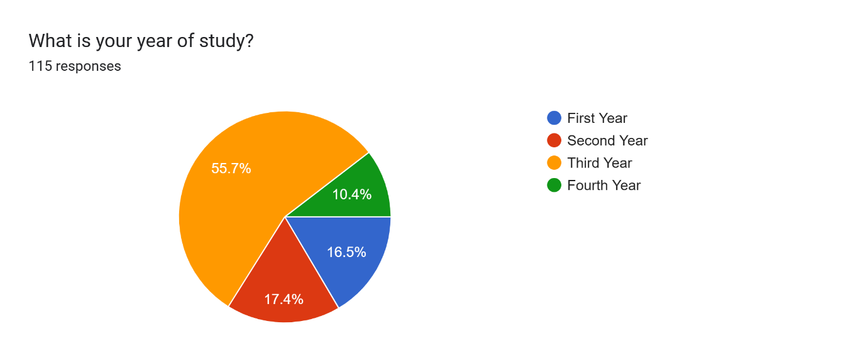

**Fig.1**

Out of a total of 115 responses collected for our survey, the majority **(55.7%)** were from third-year students. First-year students accounted for **16.5%** of the responses, followed by second-year students at **17.4%**, and fourth-year students made up the remaining **10.4%.**

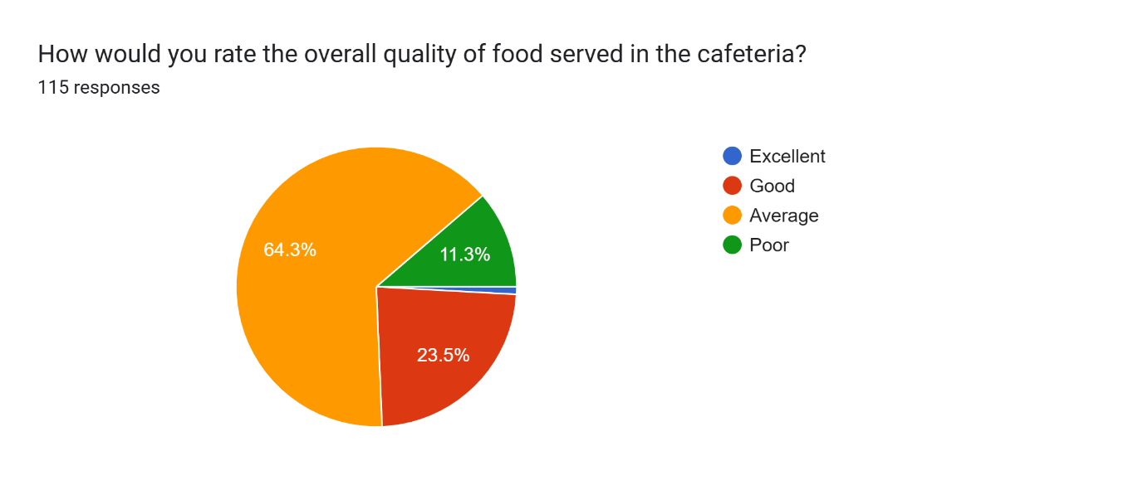

**Fig.2**

The majority of students (64.3%) rated the food as **average**. A smaller portion (23.5%) rated it as **good**, while 11.3% considered the quality to be **poor**. Only 0.9% of the students rated the food quality as **excellent.**

Forms response chart. Question title: How confident are you that the cafeteria complies with food safety and hygiene
standards?. Number of responses: 115 responses.

**Fig.3**

Only **2.6%** of students indicated that they were **very confident**, and **15.7%** felt **confident** in the cafeteria's compliance with food safety and hygiene standards. A significant portion of students (**35.7%**) remained **neutral**, while **37.4%** expressed that they were **not confident**. Additionally, **8.7%** of students stated that they were **not confident at all.**

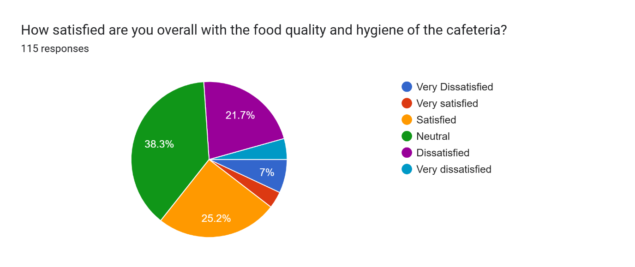

**Fig.4**

**38.3%** expressed a neutral stance, neither satisfied nor dissatisfied. Meanwhile, **25.2%** of students reported being satisfied with the cafeteria's offerings. On the other hand, **21.7%** were dissatisfied, and **7%** were very dissatisfied. Only a small percentage, **3.5%** were very satisfied with the food quality and hygiene.

### 4.2 Inferential Statistics

The chi square analysis of the survey data revealed significant relationships between various factors and overall student satisfaction with the university cafeteria. Specifically:

The p-value for the relationship between food quality and overall satisfaction was found to be 0.000351308, indicating a highly significant relationship. This suggests that the quality of food has a strong influence on overall student satisfaction.

The p-value for the variable "hygiene quality" was 0, demonstrating a highly significant relationship as well. This underscores the critical importance of hygiene in determining students' satisfaction with the cafeteria.

These results highlight the need for focused improvements in food quality and hygiene to enhance the overall dining experience for students. Here is correlation heatmap of perception about quality of food, hygiene and overall satisfaction.

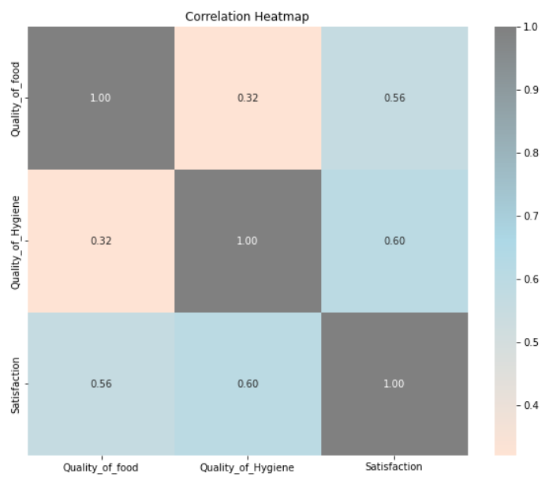

**Fig.5**

Introducing the year of study as a moderator diminishes the overall explanatory power of the model (R-squared drops), highlighting that year of study has a moderating effect only on the relationship between hygiene quality and satisfaction, but not on the relationship between food quality and satisfaction (Fig.7).

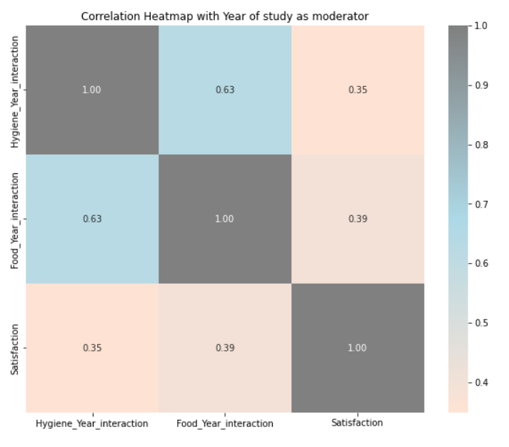

**Fig.6**

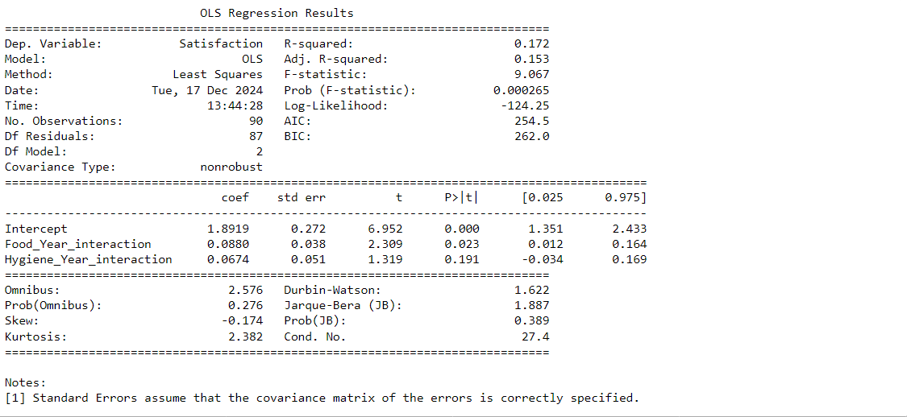

**Fig.7**

**Conclusion**

This study highlights the pivotal role of university cafeterias in shaping students' campus experiences. The findings reveal that while cafeterias serve as essential spaces for dining and social interaction, significant improvements are needed in key areas such as food quality and hygiene to meet student expectations and foster satisfaction.

The analysis demonstrated a highly significant relationship between food quality and overall satisfaction, with a p-value of 0.000351308. While 30% of respondents rated food quality as good, 50% considered it average, and 17.5% rated it poor, emphasizing the need for better ingredients, preparation, and variety. Freshness and nutritional value were deemed very important by 75% of students, further reinforcing these priorities.

Hygiene emerged as an equally critical factor, with a p-value of 0 indicating its strong influence on satisfaction. While 60% of respondents were neutral or satisfied with hygiene, 40% expressed dissatisfaction, and 50% reported encountering hygiene-related issues. of dining spaces and proper food handling practices remain pressing concerns.

Moreover, suggestions for improvement centered on hygiene and cleanliness (70%), food quality (60%), and pricing and service efficiency (30%). The frequency of cafeteria use—60% daily and 25% several times a week—indicates the need to ensure consistent quality to maintain trust and engagement.

Addressing these concerns will enhance the dining experience, foster student loyalty, and contribute to a positive campus environment. By prioritizing food quality, maintaining high hygiene standards, and responding to student feedback, universities can create cafeterias that not only meet but exceed expectations, strengthening their role as integral components of student life.

The interplay between food quality and hygiene strongly influences students' perceptions and loyalty to the cafeteria. Addressing these areas can create a positive feedback loop where improved satisfaction leads to higher usage, stronger word-of-mouth recommendations, and an enhanced reputation for the institution. These improvements are not just about meeting expectations but about exceeding them to foster a sense of pride and belonging among students.

Universities must recognize that investment in their cafeteria services is an investment in their students' well-being and academic success. By prioritizing actionable changes in food quality and hygiene universities can significantly enhance the campus dining experience. These improvements will not only satisfy current students but also leave a lasting impression, contributing to a positive institutional image and long-term student loyalty. Ultimately, a well-managed cafeteria is a cornerstone of a vibrant and thriving campus community.

# **Recommendations**

1. **Enhance Food Quality and Variety**
   1. Source High-Quality Ingredients: Ensure that all food served in the cafeteria is made with high-quality ingredients that are fresh, nutritious, and safe to eat.
   2. Expand Menu Options: Provide a variety of healthy and nutritious food options, including vegetarian, vegan, and gluten-free options, to cater to the diverse needs and preferences of students.
   3. Improve Food Preparation and Presentation: Ensure that food is prepared and presented in an appealing manner, with attention to taste, texture, and nutritional value.
2. **Improve Hygiene and Cleanliness Practices**
3. Implement Stricter Hygiene Protocols: Ensure that all food handlers and cafeteria staff adhere to strict hygiene protocols, including proper handwashing, food handling, and storage practices.
4. Maintain Cleanliness and Sanitation: Ensure that the cafeteria is maintained in a clean and sanitary condition, with regular cleaning and disinfection of all surfaces, equipment, and utensils.
5. Provide Adequate Waste Management: Ensure that adequate waste management practices are in place, including proper disposal of food waste and recyclables.
6. **Enhance Communication and Feedback Mechanisms**
7. Establish Clear Communication Channels: Establish clear and effective communication channels for students to provide feedback and suggestions on cafeteria food and services.
8. Conduct Regular Surveys and Focus Groups: Conduct regular surveys and focus groups to gather feedback from students and identify areas for improvement.
9. Respond Promptly to Student Feedback: Respond promptly to student feedback and concerns and provide explanations for any changes or improvements made.

**4. Provide Training and Education**

1. Provide Training to Cafeteria Staff: Provide training to cafeteria staff on food safety and hygiene practices, as well as customer service skills.
2. Educate Students on Food Safety and Hygiene: Educate students on food safety and hygiene practices and provide information on how to report any concerns or incidents.

**5. Continuously Monitor and Evaluate**

1. Continuously Monitor Food Quality and Hygiene: Continuously monitor food quality and hygiene in the cafeteria and take corrective action when necessary.
2. Evaluate Student Satisfaction: Regularly evaluate student satisfaction with cafeteria food and services and use the feedback to identify areas for improvement.

# **Limitations**

1. **Limited Sample Size**

The study was conducted with a sample size of 100 students, which may not comprehensively represent the entire university student body. As a result, the findings might not fully capture the diverse opinions and experiences of all students.

1. **Self-Reported Data**

The study relied on self-reported data from surveys, which is subject to biases such as overstatement, understatement, or recall bias. Respondents may not have accurately reported their experiences or satisfaction levels.

1. **Single University Focus**

The research focused on a single university, which limits the generalizability of the findings to other institutions. The cafeteria standards, student expectations, and challenges may vary significantly across different universities.

1. **Scope Constraints**

The study focused specifically on food quality, , and hygiene, excluding other potential factors influencing student satisfaction, such as pricing, service efficiency, and menu variety.

1. **Lack of Longitudinal Data**

The research captured a snapshot of student satisfaction at a specific point in time. It did not consider how satisfaction levels might change over time or in response to implemented improvements.

1. **Exclusion of Faculty and Staff Feedback**

The study only surveyed students, overlooking the perspectives of faculty and staff who also utilize cafeteria services. Including these groups could have provided a more holistic understanding of satisfaction levels.

1. **Time Constraints**

The research was conducted within a limited timeframe, potentially restricting the depth of data collection and analysis. A longer study period might have allowed for more comprehensive findings and conclusions.

Despite these limitations, the study provides valuable insights into student satisfaction with university cafeteria services and highlights actionable areas for improvement. Future research could address these limitations to build on the findings and develop a more holistic understanding of cafeteria service quality.

# **References**

Misiran, M., Md Yusof, Z., Sapiri, H., & Abdullah, I. (2022). Students Satisfaction Towards Cafeteria in University Campus – A Case Study: Students Satisfaction Towards Cafeteria in University Campus .[Vol. 4 No. 2 (2022): **Journal of Statistical Modelling & Analytics (JOSMA)**](https://ojie.um.edu.my/index.php/JOSMA/issue/view/2128)[**https://doi.org/10.22452/josma.vol4no2.2**](https://doi.org/10.22452/josma.vol4no2.2)

Wei, Y.-P. The Effect of Food Safety-Related Attributes on Customer Satisfaction of Ready-to-Eat Foods at Hypermarkets. *Sustainability* **2021**, *13*, 10554.[**https://doi.org/10.3390/su131910554**](https://doi.org/10.3390/su131910554)

Asrat Meleko, Andualem Henok, Worku Tefera, Tafesse Lamaro. Assessment of the Sanitary Conditions of Catering Establishments and Food Safety Knowledge and Practices of Food Handlers in Addis Ababa University Students’ Cafeteria. Science Journal of Public Health. Vol. 3, No. 5, 2015, pp. 733-743. doi: 10.11648/j.sjph.20150305.30

Gramling L, Byrd R, Epps L, Keith D, Lick R, Tijian, R (2005) Foodservice management and its impact on college operations. Foodservice Research International 16: 15-43.[**https://doi.org/10.1111/j.1745-4506.2005.00007.x**](https://doi.org/10.1111/j.1745-4506.2005.00007.x)

Ha, J.; Jang, S.S. Effects of service quality and food quality: The moderating role of atmospherics in an ethnic restaurant segment. *Int. J. Hosp. Manag.* **2010**, *29*, 520–529. [[**Google Scholar**](https://scholar.google.com/scholar_lookup?title=Effects+of+service+quality+and+food+quality:+The+moderating+role+of+atmospherics+in+an+ethnic+restaurant+segment&author=Ha,+J.&author=Jang,+S.S.&publication_year=2010&journal=Int.+J.+Hosp.+Manag.&volume=29&pages=520%E2%80%93529&doi=10.1016/j.ijhm.2009.12.005)]

A Study on Customer Satisfaction of College Canteens: A Case Study of Jie Yang Campus of Guangdong University of Technology [Vol. 12 No. 1 (2024): 2024 International Conference on Financial Innovation, Trade and Economic Development (FITED 2024)](https://madison-proceedings.com/index.php/mcp/item?id=9&item=item&issueid=aemr) [**https://doi.org/10.56028/aemr.12.1.401.2024**](https://doi.org/10.56028/aemr.12.1.401.2024)

The Effect of Service and Food Quality on Customer Satisfaction and Hence Customer Retention **DOI:**[**10.5539/ass.v11n23p129**](https://doi.org/10.5539/ass.v11n23p129)

[Aigbedo, H.](https://www.emerald.com/insight/search?q=Henry%20Aigbedo) and [Parameswaran, R.](https://www.emerald.com/insight/search?q=Ravi%20Parameswaran) (2004), "Importance‐performance analysis for improving quality of campus food service", [*International Journal of Quality & Reliability Management*](https://www.emerald.com/insight/publication/issn/0265-671X), Vol. 21 No. 8, pp. 876-896.[**https://doi.org/10.1108/02656710410551755**](https://doi.org/10.1108/02656710410551755)